DOUBLY LINKED LISTS

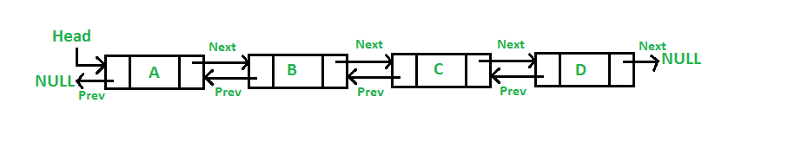

A **D**oubly **L**inked**L**ist (DLL) contains an extra pointer, typically called previous pointer, together with next pointer and data which are there in singly linked list.

**Advantages over singly linked list:**

1.A DLL can be traversed in both forward and backward direction.  
**2.** The delete operation in DLL is more efficient if pointer to the node to be deleted is given.  
**3.**We can quickly insert a new node before a given node.  
In singly linked list, to delete a node, pointer to the previous node is needed. To get this previous node, sometimes the list is traversed. In DLL, we can get the previous node using previous pointer.

In A Linked List A node can either be inserted at first, last, Uafter a given node and before a given node.

Applications:

* Can be used in Navigation Systems where both front and back Navigations are required.
* Used in webpages as buttons to move forward and backward for the visited pages.
* Used in Undo and Redo Functionality.
* Used to represent various states of games.

In our project we used the doubly linked list in order to traverse both forward and backward.

References:

Fundamentals of Data Structures in C-Elis Horowitz

<https://www.geeksforgeeks.org/doubly-linked-list/>

<https://codeforwin.org/2015/10/doubly-linked-list-data-structure-in-c.html>

The Packages imported are:

* Swing package
* Awt package
* Input -Output package
* Jxl jar(for excel)
* Util package
* Lang package

TABLE OF CONTENTS

S.NO Topic Name Pg.no

1. Abstract 01

2. Description on 02

Doubly Linked Lists

3. Functions used, 03

Design Aspects

4. Source Code 04-20

5. Files-Telugu.txt 21-23

-Hindi.txt

-English.txt

6. Output 24-27

7. References 28

TABLE OF CONTENTS

S.NO Topic Name Pg.no

1. Introduction 01

2. Goal of Implementations 02

3. Basic flow of Program 02-03

* Search
* Add

4. Packages imported 04

5. Source Code: 05-38

* Main class 05
* Ui Design 6-27
* Hostel class 28-33
* Hostel Retrieval 34-38
* Output class 39-40

-Table viewer

6. Output 41-43

7. References 43